**Emergency Use Authorization**

**Medical Community Leaders Roundtable**

November 12, 2021

Participant Bios

**________________________________________________________________________________________**

**Adarsh Bhimraj, MD, FIDSA**

**Chair of the COVID-19 Treatment and Management Guideline, Infectious Diseases Society of America (IDSA)**

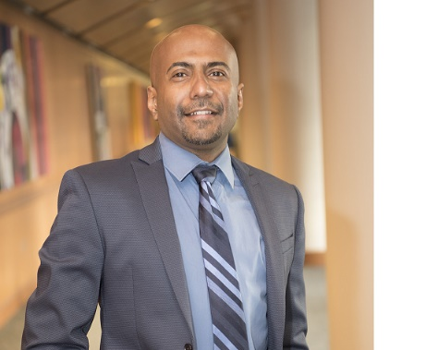Dr. Adarsh Bhimraj is the head of the section of Neurologic Infectious Diseases at Cleveland Clinic and IDSA IDWeek Chair for the annual infectious diseases conference IDWeek 2022. He is overall chair for the IDSA rapid living guideline series on COVID-19 and chair of the COVID-19 treatment and management guideline. He was a member of IDSA’s guideline panel for healthcare associated meningitis, and NCS (Neuro-Critical Care Society) guideline on cerebral ventricular drains.

Dr. Bhimraj received the 2020 Infectious Diseases Society of America citation Award. He has a passion for teaching and won the internal medicine residency teacher of the year award twice. He was an associate Program director for the Internal Medicine residency program, at Cleveland Clinic, from 2011- 2015 and was the director of clinical reasoning teaching. He likes to teach medical history and reasoning with “picture puzzles” on rounds and hosts ‘ID BugBowl” the annual jeopardy styled quiz contest for trainees at IDWeek. He is a principal course director for the Cleveland Clinic internal medicine review course for the last nine years.

**Anne Edwards, MD, FAAP**

**Chief Population Health Officer, American Academy of Pediatrics (AAP)**

Dr. Anne Edwards is the Chief Population Health Officer at American Academy of Pediatrics and leads the pediatric practice-related initiatives and programs for AAP members. Previously, she worked in Park Nicollet Health Services in Minneapolis where she practiced general pediatrics and served as chair of pediatrics and co-chair of children’s health initiatives at Health Partners, the largest consumer-directed nonprofit organization in the United States.

Dr. Edwards has held numerous leadership roles at the Academy, serving most recently as co-chair of the Task Force on Pediatric Practice Change, chair of the Committee on State Government Affairs and District VI vice chair. She served as president of the AAP Minnesota Chapter from 2006-2010. Dr. Edwards received her medical degree and completed her pediatric residency at the University of Minnesota.

**Jesse Goodman, MD, MPH**

**Director, Center on Medical Product Access, Safety and Stewardship (COMPASS)**

Dr. Jesse L. Goodman directs Georgetown COMPASS, which focuses on science-based policy and research to address unmet public health needs with an emphasis on product development and access and antimicrobial resistance and stewardship. Until February 2014, he served as the Chief Scientist of the U.S. Food and Drug Administration (FDA), a position he assumed in 2009 along with Deputy Commissioner for Science and Public Health (2009-2012). As FDA's Chief Scientist, he had broad responsibility for strategic leadership of crosscutting scientific and public health efforts, including developing and implementing FDA's Strategic Plan for Regulatory Science and FDA's public health preparedness and response and medical countermeasures efforts. In this role he led the 2009 H1N1 pandemic response, also serving on the US Department of Health and Human Services Senior Leadership team and the White House Medical Countermeasure Review. From 2003 to 2009, he was Director of FDA’s Center for Biologics Evaluation and Research (CBER), overseeing activities critical to U.S. and global preparedness and the development, evaluation, safety, quality, and availability of blood, vaccines, gene and cell therapies and other biologics, and also designated a WHO Collaborating Center. As Senior Advisor to the FDA Commissioner in 1998-2000, he initiated and, with CDC and NIH colleagues, co-chaired the United States Task Force on Antimicrobial Resistance which produced the nation’s first Public Health Action Plan to Combat Antimicrobial Resistance.

A graduate of Harvard, Dr. Goodman received his medical degree from the Albert Einstein College of Medicine and did residency and fellowship training in Medicine, Infectious Diseases and Oncology at the Hospital of the University of Pennsylvania and at the University of California in Los Angeles (UCLA), where he was also Chief Medical Resident.

**Kimberly Hanson, MD, MHS**

**Professor of Medicine, Director of Transplant Infectious Diseases and Immunocompromised Host Service, Section Head of Clinical Microbiology, and Director of Medical Microbiology Fellowship Program at University of Utah and ARUP Laboratories**

Dr. Kimberly Hanson is a board-certified physician in Adult Infectious Diseases and Medical Microbiology. She has specialized expertise in the diagnosis and management of opportunistic viral, fungal and mycobacterial diseases. Her primary clinical focus is transplant and cancer chemotherapy-related infections.

**Adrian Hernandez, MD, MHS**

**Vice Dean and Executive Director, Duke-Margolis Center for Health Policy at Duke University**

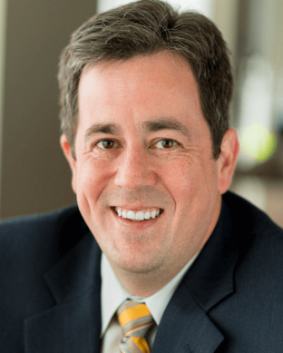Dr. Adrian F. Hernandez is a cardiologist who serves as the Vice Dean for Clinical Research at the Duke University School of Medicine. Dr. Hernandez has devoted his career to research in order to improve population health, focusing on understanding health outcomes, and closing the gap between clinical efficacy and effectiveness. An expert in trial design, use of electronic health data, health services, and regulatory science, Dr. Hernandez has led efforts to create more pragmatic clinical trials that get closer to what patients and clinicians experience every day.

Presently, he is the Coordinating Center Principal Investigator for PCORI’s National Patient-Centered Clinical Research Network (PCORnet), NIH’s Health System Collaboratory, and other pragmatic clinical trials to generate real world evidence. He is also the Coordinating Center Principal Investigator for the Baseline Health System Consortium which aims to change how clinical research is performed to integrate people in and outside of the health system, accelerate research, and improve efficiency. Dr. Hernandez was previously the Director of Health Services and Outcomes Research at the Duke Clinical Research Institute (DCRI). Under his leadership at DCRI, he played a pivotal role in leading efforts to improve patient-centered outcomes through the creation of new therapies and enhanced delivery throughout the national health system. Dr. Hernandez has consistently provided significant contributions towards the fields of heart failure, outcomes research, population health, and clinical research methodology.

**Mark A. Howell, JD**

**Senior Associate Director, Standards and Drug Policy, American Hospital Association (AHA)**

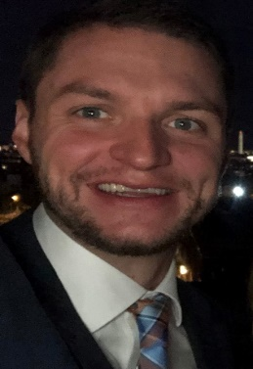Mark Howell is a Senior Associate Director of Policy at the American Hospital Association, where he has worked since October of 2018. His portfolio specifically focuses on hospital standards and conditions of participation, drug pricing and issues related to the U.S. Food and Drug Administration. Mr. Howell continues to be heavily involved in the AHA’s response to COVID-19, including work on the medical and pharmaceutical supply chain, emergency use authorizations and vaccine distribution and administration. In addition to his other work, he works on decarbonization and environmental sustainability efforts at the AHA. Prior to joining the American Hospital Association, Mr. Howell served as a Special Assistant in the Office of Congressional and Legislative Affairs at the Department of Veterans Affairs in the Obama Administration and subsequently served as legislative counsel to a Member of the U.S. House of Representatives.

He has the privilege of being a U.S. Fulbright Fellow and he received his bachelor’s degree from La Salle University and his Juris Doctorate from the Duquesne University of Law.

**Jaclyn Levy**

**Director of Public Policy, Infectious Diseases Society of America**

Jaclyn Levy is the Director of Public Policy at the Infectious Diseases Society of America (IDSA), where she oversees a broad portfolio of health policy areas including public health, research, diagnostics, workforce, and antimicrobial resistance. In addition to advancing U.S. and global policy work to combat infectious disease issues, Ms. Levy has driven COVID-19 planning and response efforts by facilitating the development of evidence-based testing recommendations, serving as a subject matter expert for congressional task forces and federal advisory groups, and facilitating coordination with public and private partners.

Prior to joining IDSA, Ms. Levy worked as a biosecurity analyst for the U.S. Department of Homeland Security; an editor for the Public Library of Science; and a consultant for trade associations and the U.S. Food and Drug Administration. She received her undergraduate degree from The George Washington University and holds a master’s in Biohazardous Threat Agents & Emerging Infectious Diseases from Georgetown University. She has authored numerous publications on global health security, molecular diagnostics, and biomedical research.

**Jacqueline A. O’Shaughnessy, PhD**

**Acting Chief Scientist, Office of The Chief Scientist, U.S. Food & Drug Administration**

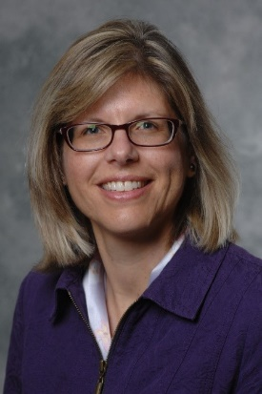Dr. JacquelineO'Shaughnessy is the FDA’s Acting Chief Scientist. In this capacity, she is responsible for leading and coordinating FDA's cross-cutting scientific and public health efforts. The Office of the Chief Scientist works closely with the FDA’s product centers, providing strategic leadership and support for the agency’s regulatory science research and innovation initiatives. Dr. O’Shaughnessy previously served as Deputy Director of the Office of the Chief Scientist (OCS), supporting the office in leading OCS cross-cutting efforts in collaboration with the FDA Centers, ORA, and Offices to advance FDA’s regulatory science and innovation initiatives, as well as ongoing strategic planning efforts of the office.

She began her career at FDA in 1996 as a pharmacologist in the FDA Center for Drug Evaluation and Research’s (CDER) former Division of Scientific Investigations, Office of Compliance. As a member of the division’s Good Laboratory Practice (GLP) and Bioequivalence (BE) Investigations Branch, Dr. O’Shaughnessy provided scientific and technical expertise on regulatory policy and complex data analysis, directed numerous multifaceted GLP and BE inspections within and outside the U.S. (including inspections related to medical countermeasures and the President's Emergency Plan for AIDS Relief (PEPFAR) initiative), and served as Acting GLP Team Lead from 2009-2011.

Dr. O’Shaughnessy received her doctorate in Pharmacology and Toxicology from the University of Medicine and Dentistry of New Jersey, Graduate School of Biomedical Sciences and completed post-doctoral training at Rutgers University, Environmental and Occupational Health Sciences Institute.

**Marcus Plescia, MD, MPH**

**Chief Medical Officer, Association of State and Territorial Health Officials**

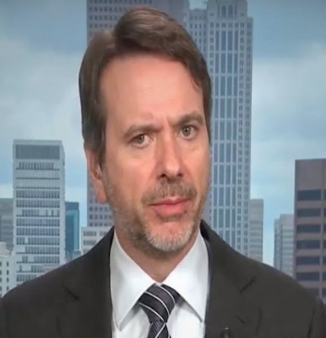Dr. Marcus Plescia is the Chief Medical Officer for the Association of State and Territorial Health Officials (ASTHO). He provides medical leadership and expertise across the agency and oversees ASTHO’s portfolio of chronic disease prevention and control programs. During the COVID-19 epidemic he has served as ASHTO’s principal spokesperson, and primary liaison to the Centers for Disease Control and Prevention. ASTHO is the national nonprofit organization representing the public health agencies of the United States, U.S. territories, and District of Columbia, as well as the more than 100,000 public health professionals these agencies employ.

Dr. Plescia has served in public health leadership roles at the local, state, and federal level in North Carolina and at the Centers for Disease Control and Prevention. In these roles he has led successful efforts to enact systemic public health interventions including expanded cancer screening coverage, prescription drug and disease reporting requirements, revised clinical guidelines, and state and local tobacco policy. He has been prominent in nationwide efforts to transform public health practice to a more population-based, strategic framework, and led the implementation of the CDC's national colorectal cancer screening program based on this approach.

Dr. Plescia received his medical degree, master’s degree in Public Health, and bachelor’s degree from the University of North Carolina at Chapel Hill. He trained in Family Medicine at Montefiore Medical Center in the Bronx, NY. He is Board Certified in Family Medicine and has practiced in a variety of settings serving homeless, urban poor and rural underserved populations. He has published extensively in the public health and family medicine literature.

**Elizabeth Sadove, JD**

**Director of Medical Countermeasures Regulatory Policy, Office of Counterterrorism and Emerging Threats, Office of Chief Scientist, Office of the Commissioner, U.S. Food & Drug Administration**

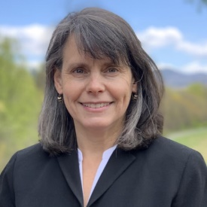Elizabeth Sadove has served as the Director of MCM Regulatory Policy for the Office of Counterterrorism and Emerging Threats in FDA’s Office of Chief Scientist for 12 years. She is responsible for advancing and implementing FDA’s statutory, regulatory, and policy framework to support the development and availability of FDA-regulated medical products for public health and national security emergencies. In this capacity, she has helped to refine, shape, interpret and implement FDA's medical countermeasure (MCM) programs, including its Emergency Use Authorization (EUA) program which has been used expansively in response to the COVID-19 pandemic. Ms. Sadove joined FDA in 2003 as Regulatory Counsel in the Center for Drug Evaluation and Research, where she specialized in addressing complex policy issues related to drug products, including revision of prescription drug labeling and safety reporting requirements. Prior to joining FDA, she handled public policy and legislative portfolios both in private practice law and for a Congressional Subcommittee of the U.S. House of Representatives. She earned her bachelor’s from Franklin & Marshall College and her Juris Doctor from George Washington University, National Law Center.

**Thomas Sparkman, JD**

**Senior Vice President of Government Affairs and Policy, American Clinical Laboratory Association (ACLA)**

Tom Sparkman was named Vice President for Government Relations in March 2013. Prior to joining ACLA, Sparkman was a senior lobbyist at a top lobbying firm in Washington representing biotech and medical device innovators, hospitals and other providers, among others. Joining the firm in 2008, he helped build coalitions on and off Capitol Hill to achieve his client’s legislative and policy goals.

Mr. Sparkman has also held positions with the National Association of State Medicaid Directors, the National Association of Chain Drug Stores, in addition to being a practicing pharmacist in Northern Virginia. He holds a bachelor’s degree in Pharmacy from Rutgers University, a master’s degree in Public Policy from Georgetown University, and a Juris Doctor from American University and is licensed as a pharmacist in Virginia and an Associate Member of the Virginia State Bar.

**FDA Foundation Staff**

**Susan C. Winckler, RPh, Esq.  
CEO, Reagan-Udall Foundation for the FDA**

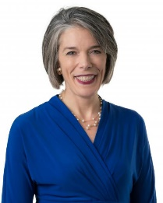Susan C. Winckler, is CEO of the Reagan-Udall Foundation for the FDA, the non-profit organization created by Congress to advance the mission of the FDA. Prior to accepting the Foundation post, she served as President of Leavitt Partners Solutions, a healthcare strategy firm founded by Gov. Michael O. Leavitt, former Secretary of the U.S. Department of Health and Human Services. Ms. Winckler directly advised C-suite executives of a wide range of organizations on public policy and regulation, business strategy, investments, and other major business matters.

As Chief of Staff for the U.S. Food and Drug Administration (2007-2009), she managed the Commissioner’s Office, served both Republican and Democratic commissioners as their senior-most staff adviser, analyzed complex policy challenges and represented FDA with myriad government entities and external stakeholders. Her earlier career service included more than a decade at the American Pharmacists Association in a series of positions of increasing responsibility.

**Lea Ann Browning-McNee, MS  
Director of Communication & Stakeholder Engagement, Reagan-Udall Foundation for the FDA**

Lea Ann Browning-McNee translates complex science, research, and policy into practical, meaningful stories relevant to the Reagan-Udall Foundation for the FDA’s stakeholders. Before joining the Foundation, Mrs. Browning-McNee helped launch BrainFutures, a national non-profit focused on promoting breakthroughs in brain health and was instrumental in bringing Mental Health First Aid to the United States during her tenure at the National Council for Behavioral Health. She also served in senior leadership positions at the Mental Health Association of Maryland and the National Mental Health Association. She holds a bachelor’s in Communications and a master’s in Writing from Towson University.